Day 8 - 27th July 2026

Jdk 18 and above

java -version
java version "26.0.2" 2026-07-21
Java(TM) SE Runtime Environment (build 26.0.2+10-55)
Java HotSpot(TM) 64-Bit Server VM (build 26.0.2+10-55, mixed mode, sharing)

mvn -v
Apache Maven 3.9.6 (bc0240f3c744dd6b6ec2920b3cd08dcc295161ae)
Maven home: C:\Program Files\apache-maven-3.9.6
Java version: 17.0.12, vendor: Oracle Corporation, runtime: C:\Program Files\Java\jdk-17
Default locale: en_IN, platform encoding: Cp1252
OS name: "windows 11", version: "10.0", arch: "amd64", family: "windows"

>mvn archetype:generate -DgroupId=com.bank -DartifactId=Demo02_DependencyInjection -DarchetypeArtifactId=maven-archetype-quickstart -DinteractiveMode=false
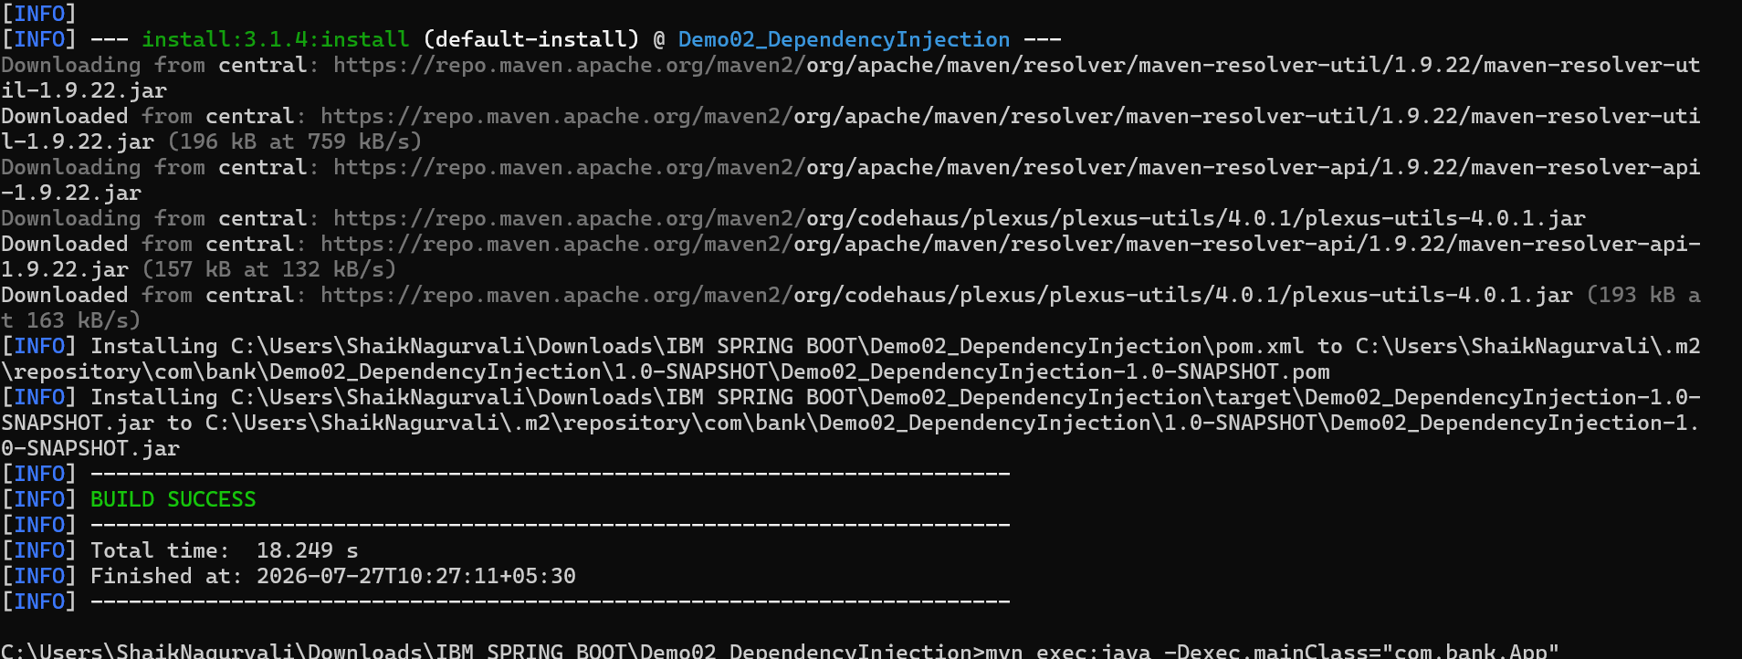

Cd folder name
Project structure
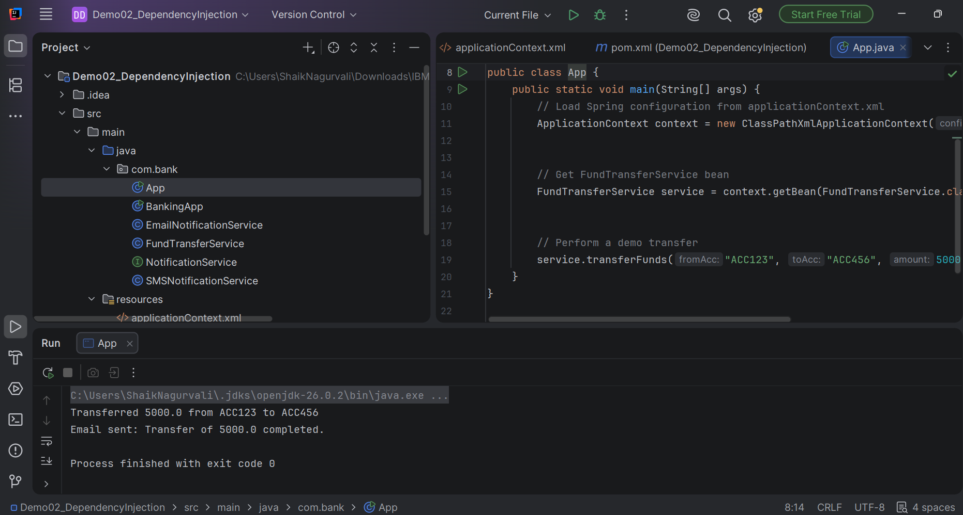

Dependency in [pom.xml
<dependency>
<groupId>org.springframework</groupId>
<artifactId>spring-context</artifactId>
<version>6.1.2</version>
</dependency>

App.java
package com.bank;
import org.springframework.context.ApplicationContext;
import org.springframework.context.support.ClassPathXmlApplicationContext;
public class App {
public static void main(String[] args) {
// Load Spring configuration from applicationContext.xml
ApplicationContext context = new ClassPathXmlApplicationContext("applicationContext.xml");
// Get FundTransferService bean
FundTransferService service = context.getBean(FundTransferService.class);
// Perform a demo transfer
service.transferFunds("ACC123", "ACC456", 5000.0);
}
}

BankingApp.java
package com.bank;
import org.springframework.context.ApplicationContext;
import org.springframework.context.support.ClassPathXmlApplicationContext;
public class BankingApp {
public static void main(String[] args) {
ApplicationContext context = new ClassPathXmlApplicationContext("applicationContext.xml");
FundTransferService service = context.getBean(FundTransferService.class);
service.transferFunds("ACC123", "ACC456", 5000.0);
}
}

EmailNotificationService .java
package com.bank;
import org.springframework.stereotype.Service;
@Service
public class EmailNotificationService implements NotificationService {
@Override
public void notifyCustomer(String message) {
System.out.println("Email sent: " + message);
}
}

FundTransferService.java
package com.bank;
import org.springframework.beans.factory.annotation.Autowired;
import org.springframework.stereotype.Component;
@Component
public class FundTransferService {
private final NotificationService notificationService;
@Autowired
public FundTransferService(NotificationService notificationService) {
this.notificationService = notificationService;
}
public void transferFunds(String fromAcc, String toAcc, double amount) {
System.out.println("Transferred " + amount + " from " + fromAcc + " to " + toAcc);
notificationService.notifyCustomer("Transfer of " + amount + " completed.");
}
}

NotificationService.java
package com.bank;
public interface NotificationService {
void notifyCustomer(String message);
}
SMSNotificationService.java
package com.bank;
public class SMSNotificationService implements NotificationService {
@Override
public void notifyCustomer(String message) {
System.out.println("SMS sent: " + message);
}
}

In src/main add resources folder

applicationContext.xml
<beans xmlns="http://www.springframework.org/schema/beans"
xmlns:xsi="http://www.w3.org/2001/XMLSchema-instance"
xsi:schemaLocation="http://www.springframework.org/schema/beans
http://www.springframework.org/schema/beans/spring-beans.xsd">
<!-- Choose implementation -->
<bean id="notificationService" class="com.bank.EmailNotificationService"/>
<!-- Inject dependency -->
<bean id="fundTransferService" class="com.bank.FundTransferService">
<constructor-arg ref="notificationService"/>
</bean>
</beans>

Task 01:
What do you understand by Spring frame work?
Spring Framework is an open-source Java framework used to develop enterprise applications. It provides features such as Dependency Injection, IoC, AOP, transaction management, and Spring MVC to build scalable and maintainable applications.

Task 02:
What is spring boot?
Spring Boot is an extension of the Spring Framework that simplifies application development by providing auto-configuration, starter dependencies, and an embedded web server.

Task 03:
What is the diff b/w spring framework and spring boot?
Spring Framework | Spring Boot
Core Java framework | Extension of Spring Framework
Requires manual configuration | Provides auto-configuration
Needs external web server | Uses embedded Tomcat/Jetty
Manual dependency management | Starter dependencies
More setup required | Less setup required
Suitable for enterprise applications | Suitable for microservices and REST APIs

Task 04:
What is Dependency Injection?
Definition:
Dependency Injection (DI) is a design pattern in which the Spring IoC Container creates and injects the required objects (dependencies) into a class instead of the class creating them itself.

Task 05:
create a simple OrderService that depends on a PaymentService. Instead of creating objects manually, inject them.
interfaces:
paymentService ' ----> credit card or debit card class
and orderservice ---> PaymentService implementation class

PaymentSerivce.java
package org.example;
public interface PaymentService {
void makePayment(double amount);
}

CreditCardPayment.java
package org.example;
public class CreditCardPayment implements PaymentService {
@Override
public void makePayment(double amount) {
System.out.println("Payment of Rs." + amount + " made using Credit Card.");
}
}

DebitCardPayment.java

package org.example;
public class DebitCardPayment implements PaymentService {
@Override
public void makePayment(double amount) {
System.out.println("Payment made using Debit Card");
}
}

OrderService.java
package org.example;
public class OrderService {
private PaymentService paymentService;
public OrderService() {
}
public void setPaymentService(PaymentService paymentService) {
this.paymentService = paymentService;
}
public void placeOrder(double amount) {
System.out.println("Order placed successfully.");
paymentService.makePayment(amount);
}
}

App.java
package org.example;
import java.util.Scanner;
import org.springframework.context.ApplicationContext;
import org.springframework.context.support.ClassPathXmlApplicationContext;
public class App {
public static void main(String[] args) {
ApplicationContext context =
new ClassPathXmlApplicationContext("applicationContext.xml");
OrderService orderService =
(OrderService) context.getBean("orderService");
Scanner sc = new Scanner(System.in);
System.out.print("Enter payment amount: ");
double amount = sc.nextDouble();
orderService.placeOrder(amount);
sc.close();
}
}

applicationContext.xml

<?xml version="1.0" encoding="UTF-8"?>
<beans xmlns="http://www.springframework.org/schema/beans"
xmlns:xsi="http://www.w3.org/2001/XMLSchema-instance"
xsi:schemaLocation="
http://www.springframework.org/schema/beans
https://www.springframework.org/schema/beans/spring-beans.xsd">
<!-- Payment Bean -->
<bean id="paymentService"
class="org.example.CreditCardPayment"/>
<!-- Order Bean -->
<bean id="orderService"
class="org.example.OrderService">
<property name="paymentService"
ref="paymentService"/>
</bean>
</beans>

Pom.xml
<project xmlns="http://maven.apache.org/POM/4.0.0"
xmlns:xsi="http://www.w3.org/2001/XMLSchema-instance"
xsi:schemaLocation="http://maven.apache.org/POM/4.0.0
https://maven.apache.org/xsd/maven-4.0.0.xsd">
<modelVersion>4.0.0</modelVersion>
<groupId>org.example</groupId>
<artifactId>PaymentInformationSpring</artifactId>
<version>1.0-SNAPSHOT</version>
<dependencies>
<dependency>
<groupId>org.springframework</groupId>
<artifactId>spring-context</artifactId>
<version>6.1.2</version>
</dependency>
</dependencies>
</project>

Task 06:

—----------------------------------------------------------------------------------------------------------------------------*************************************************************************************************************
Dependency Check, Inner beans and Scopes *************************************************************************************************************
—---------------------------------------------------------------------------------------------------------------------------

In cmd move to projects folder

mvn archetype:generate -DgroupId=com.bank -DartifactId=DependencyChk_InrBns_BnsScop -DarchetypeArtifactId=maven-archetype-quickstart -DinteractiveMode=false

Dependency check : spring can validate weather req props are set or not

App.java
package org.example;
import org.springframework.context.ApplicationContext;
import org.springframework.context.support.ClassPathXmlApplicationContext;
public class App {
public static void main(String[] args) {
ApplicationContext context =
new ClassPathXmlApplicationContext("applicationContext.xml");
// Bank Account
BankAccount account =
context.getBean("bankAccount", BankAccount.class);
account.display();
System.out.println();
// Inner Bean
Customer customer =
context.getBean("customer", Customer.class);
customer.display();
System.out.println();
// Singleton Scope
BankAccount acc1 =
context.getBean("singletonAccount", BankAccount.class);
BankAccount acc2 =
context.getBean("singletonAccount", BankAccount.class);
System.out.println("Singleton same object? " + (acc1 == acc2));
// Prototype Scope
BankAccount acc3 =
context.getBean("prototypeAccount", BankAccount.class);
BankAccount acc4 =
context.getBean("prototypeAccount", BankAccount.class);
System.out.println("Prototype same object? " + (acc3 == acc4));
}
}

BankAccount.java
package org.example;
public class BankAccount {
private int accountId;
private String accountHolder;
public void setAccountId(int accountId) {
this.accountId = accountId;
}
public void setAccountHolder(String accountHolder) {
this.accountHolder = accountHolder;
}
public void display() {
System.out.println("Account ID: " + accountId +
", Holder: " + accountHolder);
}
}

Address.java
package org.example;
public class Address {
private String city;
public void setCity(String city) {
this.city = city;
}
public String getCity() {
return city;
}
}

Customer.java
package org.example;
public class Customer {
private String name;
private Address address;
public void setName(String name) {
this.name = name;
}
public void setAddress(Address address) {
this.address = address;
}
public void display() {
System.out.println("Customer: " + name);
System.out.println("Address: " + address.getCity());
}
}

applicationContext.xml
<?xml version="1.0" encoding="UTF-8"?>
<beans xmlns="http://www.springframework.org/schema/beans"
xmlns:xsi="http://www.w3.org/2001/XMLSchema-instance"
xsi:schemaLocation="
http://www.springframework.org/schema/beans
https://www.springframework.org/schema/beans/spring-beans.xsd">
<!-- Bank Account -->
<bean id="bankAccount"
class="org.example.BankAccount">
<property name="accountId" value="101"/>
<property name="accountHolder" value="Prasunamba"/>
</bean>
<!-- Customer with Inner Bean -->
<bean id="customer"
class="org.example.Customer">
<property name="name" value="Prasunamba"/>
<property name="address">
<bean class="org.example.Address">
<property name="city" value="Bengaluru"/>
</bean>
</property>
</bean>
<!-- Singleton Scope -->
<bean id="singletonAccount"
class="org.example.BankAccount"
scope="singleton">
<property name="accountId" value="201"/>
<property name="accountHolder" value="Singleton User"/>
</bean>
<!-- Prototype Scope -->
<bean id="prototypeAccount"
class="org.example.BankAccount"
scope="prototype">
<property name="accountId" value="202"/>
<property name="accountHolder" value="Prototype User"/>
</bean>
</beans>

Pom.xml
<?xml version="1.0" encoding="UTF-8"?>
<project xmlns="http://maven.apache.org/POM/4.0.0"
xmlns:xsi="http://www.w3.org/2001/XMLSchema-instance"
xsi:schemaLocation="http://maven.apache.org/POM/4.0.0 http://maven.apache.org/xsd/maven-4.0.0.xsd">
<modelVersion>4.0.0</modelVersion>
<groupId>org.example</groupId>
<artifactId>AccountProject</artifactId>
<version>1.0-SNAPSHOT</version>
<properties>
<maven.compiler.source>26</maven.compiler.source>
<maven.compiler.target>26</maven.compiler.target>
<project.build.sourceEncoding>UTF-8</project.build.sourceEncoding>
</properties>
<dependencies>
<!-- Spring Context -->
<dependency>
<groupId>org.springframework</groupId>
<artifactId>spring-context</artifactId>
<version>6.1.2</version>
</dependency>
</dependencies>
</project>

